**Case Study: Scheduling via PDM**

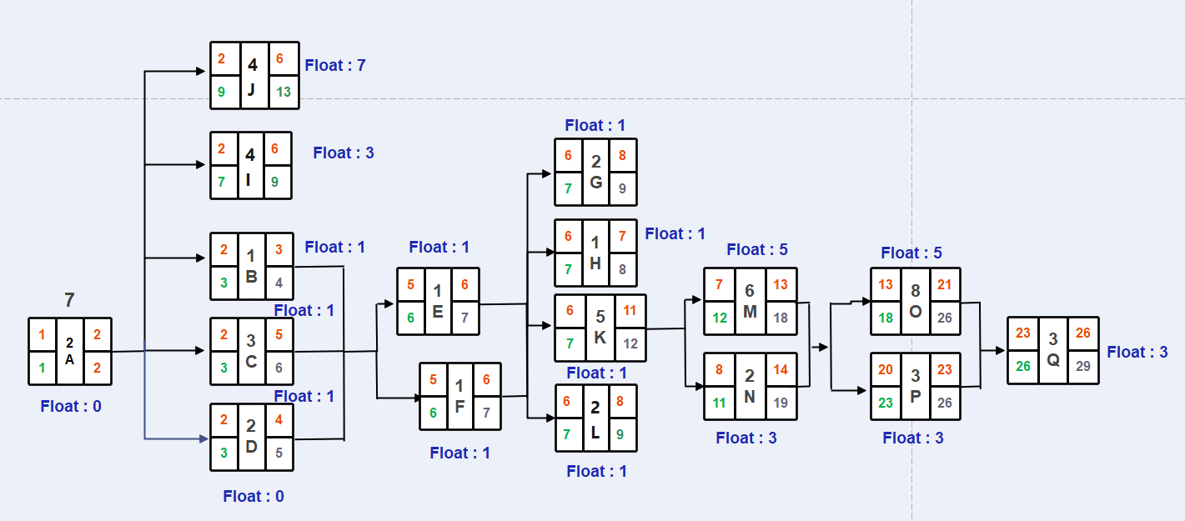

**Delivery Date:** 26 Days Early Finish – 29 Days Late Finish